INVITATION FOR
NEGOTIATED PROCUREMENT UNDER TWO FAILED BIDDINGS

SUPPLY AND DOOR-TO-DOOR DELIVERY OF MANIPULATIVE MATERIALS FOR LEARNERS WITH DISABILITY TO THE RECIPIENT SCHOOLS IN REGION IX

- The Department of Education Region IX intends to apply the sum of Five Million Four Hundred Five Thousand Four Hundred Five Pesos (Php 5,405,405.00) being the ABC to payments under the contract for the Supply and Door-to-Door Delivery of Manipulative Materials for Learners with Disability to the Recipient Schools in Region IX.

- The Department of Education Region IX, through the Bids and Awards Committee (BAC) now invites technically, legally, and financially capable suppliers for the said project.

- The Procurement procedure for this requirement is Negotiated Procurement under Two-Failed Bidding pursuant to Section 53.1 of 2016 revised Implementing Rules and Regulations (IRR) of Republic Act (RA) No. 9184.

The selection of the successful offer shall be based on the best and final offer that will be submitted on the set deadline by the BAC and which would meet the minimum technical specifications required.

- The interested bidders may obtain further information from the BAC Secretariat at the address given below from October 23, 2025 to November 11, 2025, Monday to Friday, at 8:00AM to 5:00PM.

- A complete set of Bidding Documents may be acquired by interested Bidders on October 23, 2025 from the given address and website(s) below upon payment of the applicable fee for the Bidding Documents, pursuant to the latest Guidelines issued by the GPPB, in the amount of Ten Thousand (Php 10,000.00).

- Hereunder stated is the schedule of bidding activities:

Activities | Schedule | Venue
1. Negotiation Meeting | October 30, 2025 at 2:00 pm | Conference Hall, DepEd RO-9, President Corazon C. Aquino, Regional Government Center, Balintawak, Pagadian City
2. Deadline for the Submission of Negotiation Documents (Proposal) | November 11, 2025 at 1:30 pm
3. Opening of Negotiation  Documents (Proposal) | November 11, 2025 at 2:00 pm

- Two (2) copies of the proposals (one original and one copy) must be submitted to the BAC which must be duly received by the BAC Secretariat through manual submission at the office address indicated above on or before 1:30 pm of November 11, 2025. Late submission shall not be accepted.

- Interested bidders shall submit the following documents in sealed envelopes, labeled as “Negotiated Procurement for Two-Failed Biddings”, with the title of the procurement project, name of the bidder, address, the contact details of the bidder, addressed to the BAC.

- Eligibility and Technical Documents

- Valid PhilGEPS Registration Certificate (Platinum Membership), including the Annex/es;
- Statement of the prospective bidder of all its ongoing government and private
contracts, including contracts awarded but not yet started, if any, whether similar or not similar in nature and complexity to the contract to be bid;
- Statement of Bidder’s Single Largest Completed Contract (SLCC) similar to the contract to be bid. For this purpose, the definition of similar contracts shall refer to Supply and Door-to-Door Delivery of Manipulative Materials for Learners with Disability to the Recipient Schools in Region IX which shall be completed within the last 5 years prior to the date of submission of the best and final offer.
- Bid Security in any of the following form as prescribed under the 2016 revised IRR of RA 9184:

- The amount of not less than 2% of ABC, if bid security is in cash, cashier’s/manager’s check, bank draft/guarantee or irrevocable letter of credit; or
- The amount of not less than 5% of ABC if bid security is in Surety Bond.
- Bid Securing Declaration.

- Conformity with the Technical Specifications (Annex “A”);
- Conformity with the Schedule of Requirements (Annex “B”);
- Notarized Omnibus Sworn Statement (OSS) supported with Notarized Secretary’s Certificate in case of a corporation or cooperative; in case of partnership or single proprietorship, the bidder shall submit Special Power of Attorney executed by the partners or single proprietorship; whichever is applicable.

In case of Joint Venture, Special Power of Attorney shall be submitted by all members of the joint venture giving full power and authority to its officer to sign the OSS and do acts to represent the Bidder.
- If applicable, a duly signed joint venture agreement (JVA) in case the joint venture is already in existence or duly notarized statement from all the potential joint venture partners stating that they will enter into and abide by the provisions of the JVA in the instance that the bid is successful.

- Financial Documents

- Bid Form
- Price Schedule

- Special Conditions of the Contract (Annex “C”) shall form part of the contract. Other conditions of the contract shall be governed by the implementation of the rules and regulations of RA 9184 and other related and applicable laws.
- The Department of Education Region IX reserves the right to reject any and all bids, declare a failure of bidding, or not award the contract at any time prior to contract award in accordance with Sections 35.6 and 41 of the 2016 revised IRR of RA No. 9184, without thereby incurring any liability to the affected bidder or bidders.

JERRY M. IJIRANI
BAC Secretariat
DepEd RO-9, President Corazon C. Aquino Regional Government Center
Balintawak, Pagadian City
Email: (region9.bac@deped.gov.ph)
Website: www.depedro9.info; www.ro9-deped.com

Issued this 23rd day of October 2025.

DR. GREGORIO CYRUS R. ELEJORDE, CESO V
Assistant Regional Director
Chairperson, Bids and Awards Committee

ANNEX A

Technical Specifications
INSTRUCTIONS: Bidders must state here either “Comply” or “Not Comply” against each of the individual parameters of each Specification stating the corresponding performance parameter of the equipment offered. Statements of “Comply” or “Not Comply” must be supported by evidence in a Bidders Bid and cross-referenced to that evidence. Evidence shall be in the form of manufacturer’s un-amended sales literature, unconditional statements of specification and compliance issued by the manufacturer, samples, independent test data etc., as appropriate. A statement that is not supported by evidence or is subsequently found to be contradicted by the evidence presented will render the Bid under evaluation liable for rejection. A statement either in the Bidder's statement of compliance or the supporting evidence that is found to be false either during Bid evaluation, post-qualification or the execution of the Contract may be regarded as fraudulent and render the Bidder or supplier liable for prosecution subject to the applicable laws and issuances.

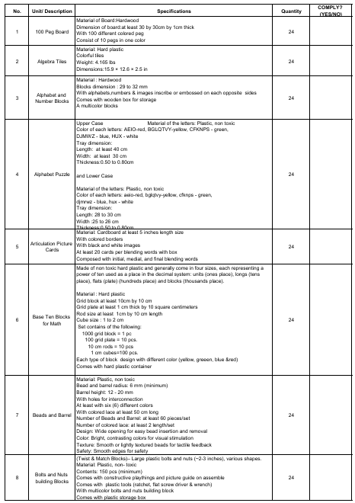
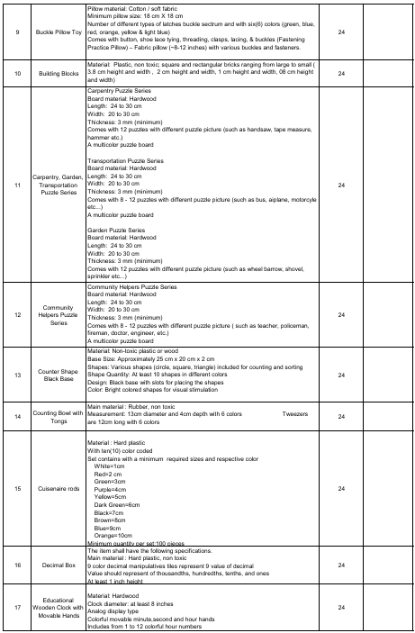
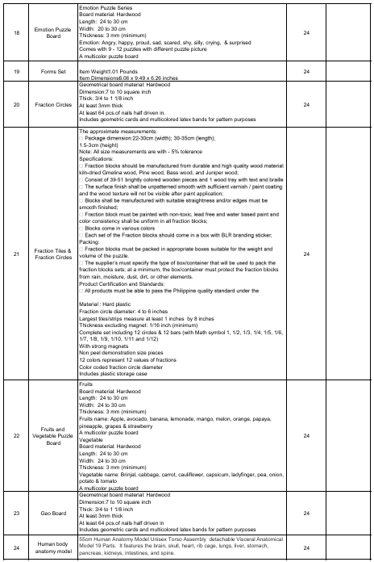
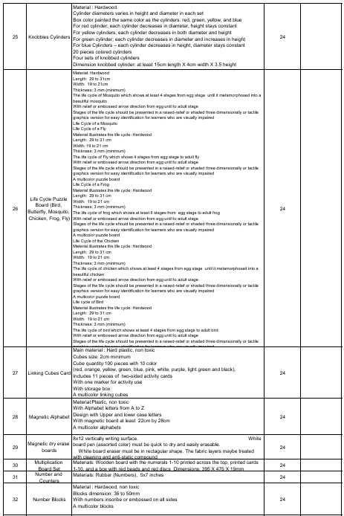
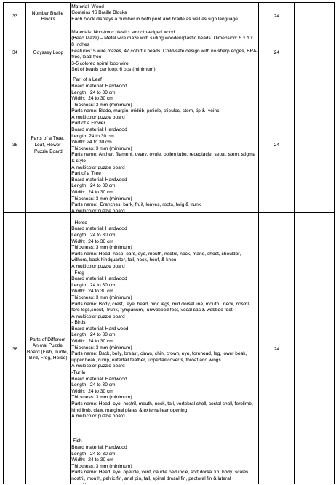
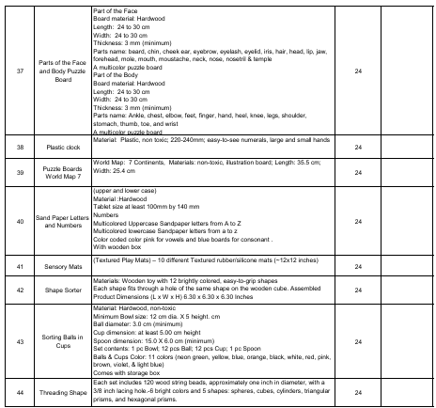
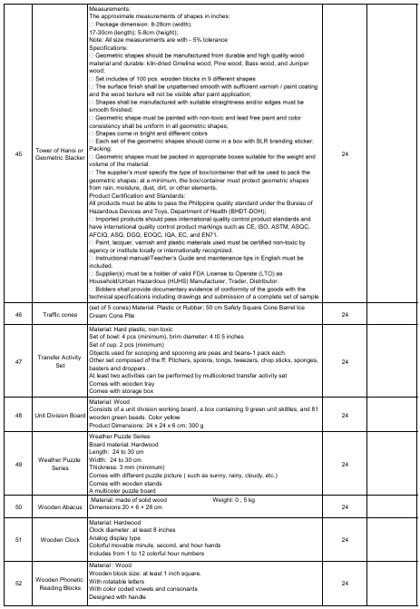
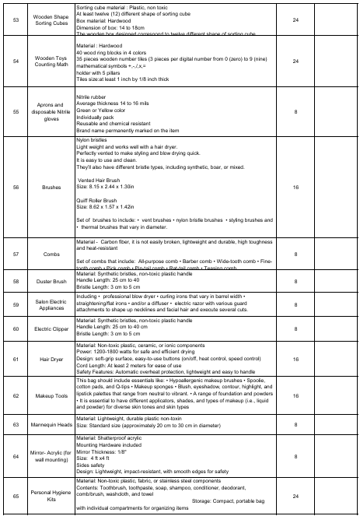
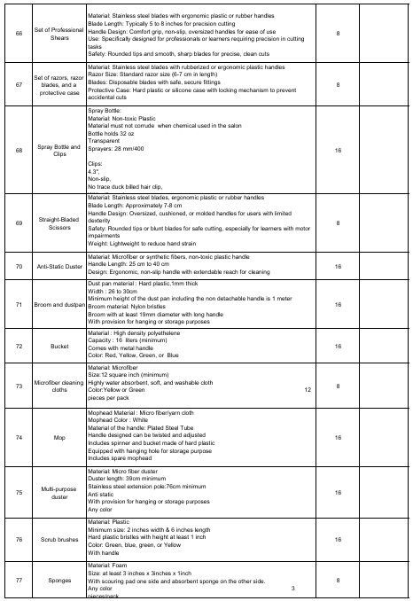
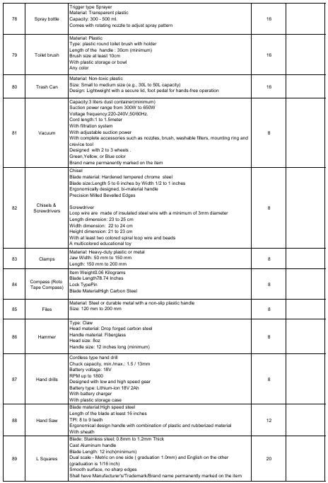
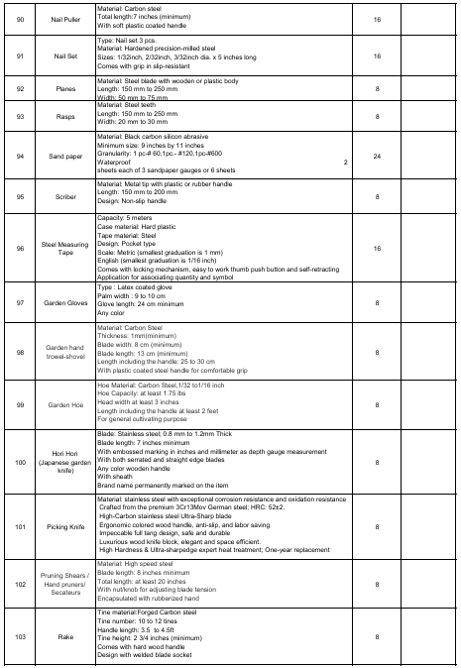
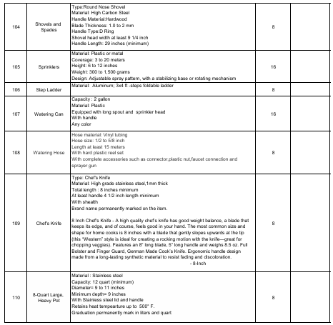
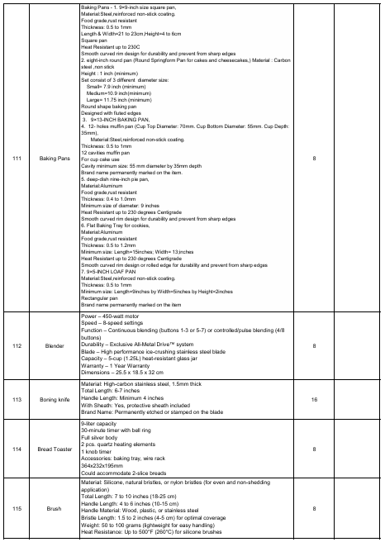
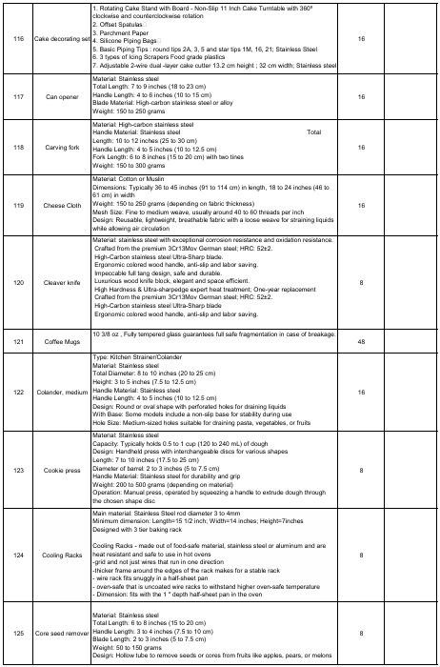
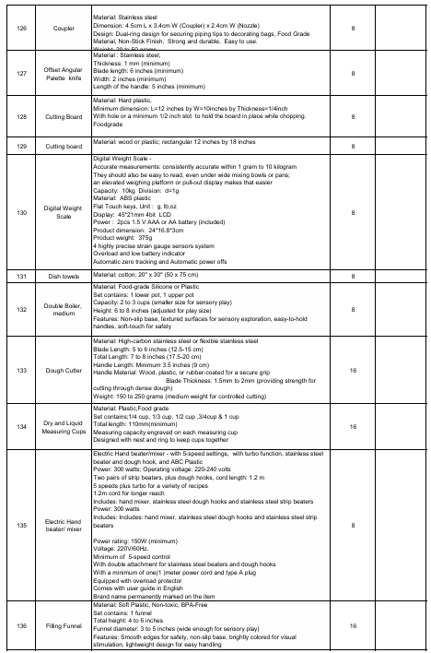
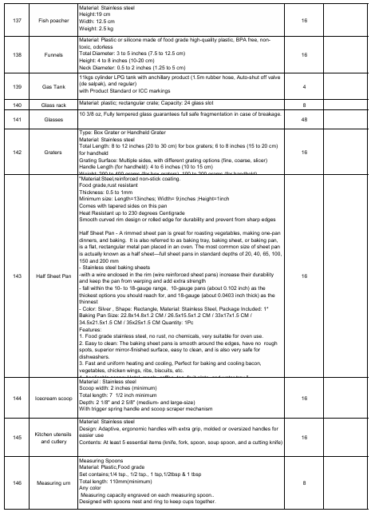
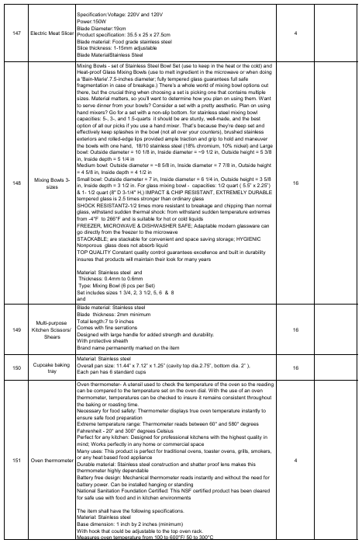
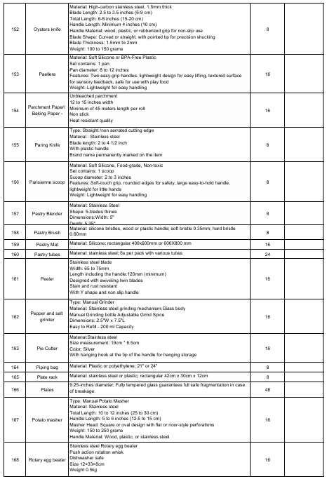
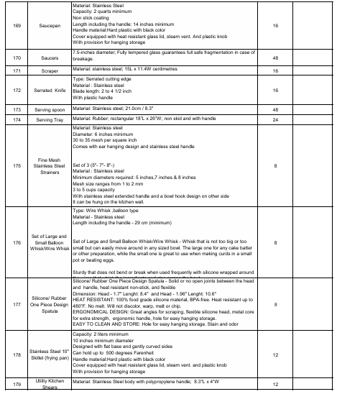
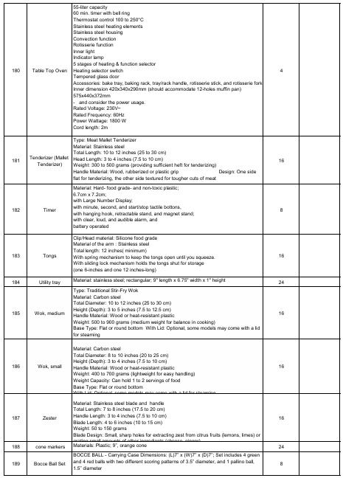
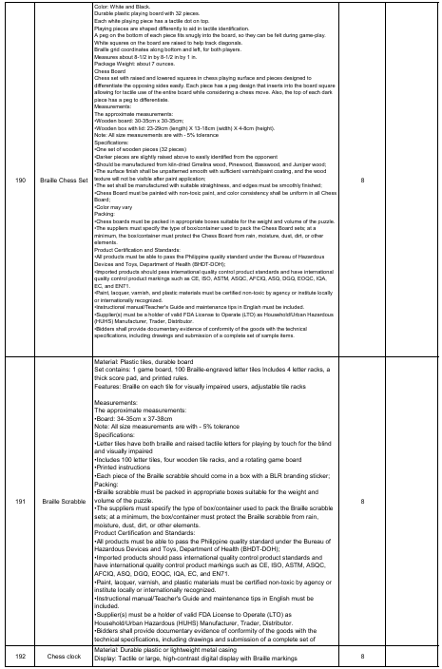
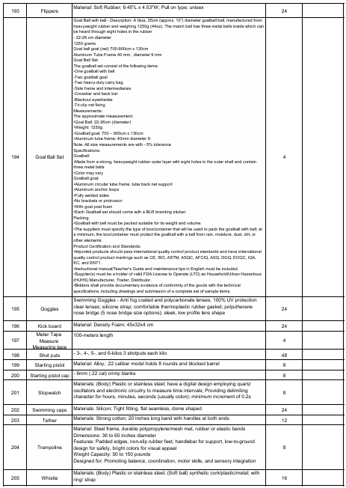
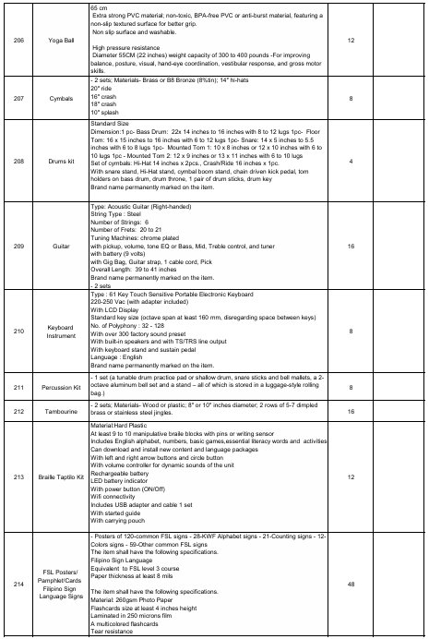
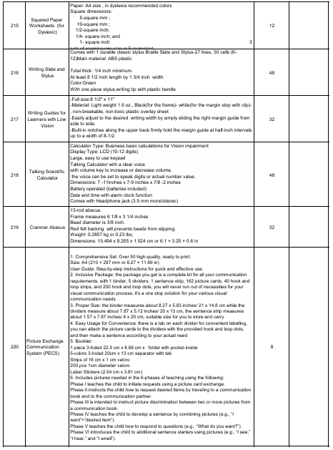
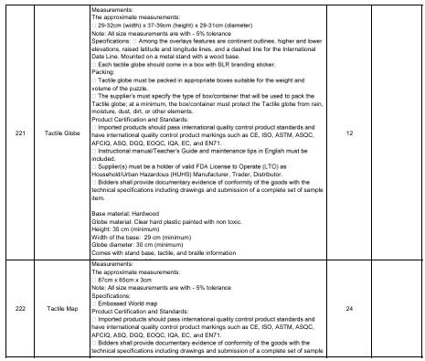

ANNEX B

Schedule of Requirements

The delivery schedule expressed below stipulates the date of delivery to the project site

Item No. | Description | Quantity | Unit | Contract Duration
1 | Supply and Door-to-Door Delivery of Manipulative Materials for Learners with Disability to the Recipient Schools in Region IX | 1 | Lot | Within 60 CD upon receipt of Notice to Proceed (NTP)

STATEMENT OF COMPLIANCE

I hereby commit to provide the above specified requirements in compliance with the Technical Specifications for the Project: Supply and Door-to-Door Delivery of Manipulative Materials for Learners with Disability to the Recipient Schools in Region IX.

____________________________________________
Name and Signature of Bidder’s Authorized Representative

ANNEX C

Special Conditions of Contract

Delivery and Documents –

For purposes of the Contract, “EXW,” “FOB,” “FCA,” “CIF,” “CIP,” “DDP” and other trade terms used to describe the obligations of the parties shall have the meanings assigned to them by the current edition of INCOTERMS published by the International Chamber of Commerce, Paris. The Delivery terms of this Contract shall be as follows:

The delivery terms applicable under this Contract shall be DDP (Duties Delivered Paid) in accordance with INCOTERMS. Risk and title to the goods shall pass from the Supplier to DepEd RO IX upon receipt and final acceptance of the goods at the designated delivery site: Recipient Schools in Region IX.

Delivery of the Goods shall be made by the Supplier in accordance with the terms specified in Section VI (Schedule of Requirements).

For purposes of this Clause, Supply and Door-to-Door Delivery of Learning Tools and Equipment for Technical-Science and Mathematics Equipment (LTE-SME) at the delivery site shall be inspected by the Authorized Receiving Personnel.

Upon delivery of the goods to the delivery site, the Supplier shall notify DepEd RO IX and present the following document:

- Original and four copies of the Supplier’s invoice showing goods’ description, quantity, unit price, and total amount.

Intellectual Property Rights

The Supplier shall indemnify DepEd RO IX against all third-party claims of infringement of patent, trademark, or industrial design rights arising from use of the goods or any part thereof.

Incidental Services –

The Contract price for the Goods/Services shall include the prices charged by the Supplier for incidental services and shall not exceed the prevailing rates charged to other parties by the Supplier for similar services.
Liquidated Damages –
When the supplier fails to satisfactorily deliver goods under the contract within the specified delivery schedule, inclusive of duly granted time extensions, if any, the supplier shall be liable for damages for the delay and shall pay the procuring entity liquidated damages, not by way of penalty, an amount equal to one-tenth (1/10) of one percent (1%) of the cost of the delayed goods scheduled for delivery for every day of delay until such goods are finally delivered and accepted by the procuring entity concerned. The procuring entity need not prove that it has incurred actual damages to be entitled to liquidated damages. Such amount shall be deducted from any money due or which may become due to the supplier, or collected from any securities or warranties posted by the supplier, whichever is convenient to the procuring entity concerned. In case the total sum of liquidated damages reaches ten percent (10%) of the total contract price, the procuring entity concerned may rescind the contract and impose appropriate sanctions over and above the liquidated damages to be paid.
Force Majeure –

The Contractor shall not be liable for the forfeiture of its Performance Security, liquidated damages, or termination for default if and to the extent that its delay in performance or other failure to perform its obligations under the Contract is the result of a force majeure.

For purpose of this Contract the terms "force majeure" and "fortuitous event" may be used interchangeably. In this regard, a fortuitous event or force majeure shall be interpreted to mean an event which the Contractor could not have foreseen, or which though foreseen, was inevitable. It shall not include ordinary unfavorable weather conditions, and any other cause the effects of which could have been avoided with the exercise of reasonable diligence by the Contractor. Such events may include, but not limited to, acts of the Procuring Entity in its sovereign capacity, wars or revolutions, fires, floods, epidemics, quarantine restrictions, and freight embargoes.
Inspections

Pursuant to DO 041, s. 2021, inspection or pre-delivery inspection (PDI), where applicable for goods to be delivered, shall be conducted by DepEd through the duly designated Inspectorate Team. The inspection or PDI shall be made upon notice to the DepEd RO IX of the readiness of the goods for inspection.

The Supplier shall coordinate with DepEd RO IX, through the Asset Management Section (AMS), on the conduct of inspection or pre-delivery inspection (PDI). Any request for inspection or PDI shall be done in writing, and contain the following information:

a. Project Title and Contract Number;
b. Specific goods for inspection;
c. Quantity of goods for inspection;
d. Venue/Address of inspection site; and
e. Proposed schedule of inspection which must be at least ten (10) calendar days from the submission of the letter request.

The request for inspection or PDI shall be addressed to the Asset Management Section (AMS).

Warranty

A THREE MONTH warranty for the expendable goods will be applied. The said warranty period shall reckon from the date of issuance of the Certificate of Final Acceptance by the DepEd RO IX that the delivered Goods have been duly inspected and accepted (i.e. final acceptance).

LIST OF ALL ONGOING GOVERNMENT & PRIVATE CONTRACTS INCLUDING CONTRACTS AWARDED BUT NOT YET STARTED

Business Name: _______________________________________________________
Business Address : _____________________________________________________

Name of Contract/  Project Cost | Owner’s Name  a. Address  b. Telephone Nos. | Nature of  Work | Bidder’s Role |  | Date Awarded  a. Date  Started  b. Date of  Completion | % of  Accomplishment |  | Value of  Outstanding  Works /  Undelivered  Portion
Name of Contract/  Project Cost | Owner’s Name  a. Address  b. Telephone Nos. | Nature of  Work | Description | % | Date Awarded  a. Date  Started  b. Date of  Completion | Planned | Actual | Value of  Outstanding  Works /  Undelivered  Portion
Government
Private

Note: (In case of no ongoing contract, the bidder shall submit this duly signed form and indicate “No ongoing contracts” or “None” or “Not Applicable (N/A)” under the Column for Name of Contract (first column from left)

Submitted by: __________________________________________________
Printed Name and Signature of Authorized Representative
Designation: _________________________

Date: _______________________________
Contact No.: _________________________
Email address:

STATEMENT IDENTIFYING THE SINGLE LARGEST COMPLETED CONTRACT

Business Name :____________________________________________

Business Address : ____________________________________________

Name of Contract | a. Owner's Name  b. Address  c. Telephone Nos. | Nature of  Work | Bidder's Role |  | a. Amount at Award  b. Amount at  Completion  c. Duration | a. Date Awarded  b. Contract Effectivity  c. Date Completed  d. Contract Performance  certified by End User
Name of Contract | a. Owner's Name  b. Address  c. Telephone Nos. | Nature of  Work | Description | % | a. Amount at Award  b. Amount at  Completion  c. Duration

Note: The bidder shall be able to support this statement with:

Duly signed Contracts/Purchase Orders (POs)/ Agreements/Memoranda of Agreement (MOA)/Notices of Award (NOA)/Job Orders or Notices to Proceed (NTP) with the corresponding Certificates of Completion of Delivery (CCDs)/ Certificates of Final Acceptance (CFAs)/duly signed Delivery Receipts (DRs), or duly accomplished Inspection and Acceptance Reports (IARs)

Submitted by : _____________________________________________________
(Printed Name and Signature)
Designation : _____________________________

Date: ___________________________________
Contact No.: _____________________________
Email address: ____________________________

Bid Securing Declaration Form
[shall be submitted with the Bid if bidder opts to provide this form of bid security]

REPUBLIC OF THE PHILIPPINES)
CITY OF ) S.S.

BID SECURING DECLARATION
Project Identification No.: [Insert number]

To: [Insert name and address of the Procuring Entity]

I/We, the undersigned, declare that:

- I/We understand that, according to your conditions, bids must be supported by a Bid Security, which may be in the form of a Bid Securing Declaration.
- I/We accept that: (a) I/we will be automatically disqualified from bidding for any procurement contract with any procuring entity for a period of two (2) years upon receipt of your Blacklisting Order; and, (b) I/we will pay the applicable fine provided under Section 6 of the Guidelines on the Use of Bid Securing Declaration, within fifteen (15) days from receipt of the written demand by the procuring entity for the commission of acts resulting to the enforcement of the bid securing declaration under Sections 23.1(b), 34.2, 40.1 and 69.1, except 69.1(f),of the IRR of RA No. 9184; without prejudice to other legal action the government may undertake.
- I/We understand that this Bid Securing Declaration shall cease to be valid on the following circumstances:
  - Upon expiration of the bid validity period, or any extension thereof pursuant to your request;
  - I am/we are declared ineligible or post-disqualified upon receipt of your notice to such effect, and (i) I/we failed to timely file a request for reconsideration or (ii) I/we filed a waiver to avail of said right; and
  - I am/we are declared the bidder with the Lowest Calculated Responsive Bid, and I/we have furnished the performance security and signed the Contract.

IN WITNESS WHEREOF, I/We have hereunto set my/our hand/s this day of [month] [year] at [place of execution].

[Insert NAME OF BIDDER OR ITS AUTHORIZED REPRESENTATIVE]
[Insert signatory’s legal capacity]
Affiant

[Jurat]
[Format shall be based on the latest Rules on Notarial Practice]

Omnibus Sworn Statement (Revised)
[shall be submitted with the Bid]
_________________________________________________________________________

REPUBLIC OF THE PHILIPPINES )
CITY/MUNICIPALITY OF ______ ) S.S.
AFFIDAVIT
I, [Name of Affiant], of legal age, [Civil Status], [Nationality], and residing at [Address of Affiant], after having been duly sworn in accordance with law, do hereby depose and state that:

- [Select one, delete the other:]
[If a sole proprietorship:] I am the sole proprietor or authorized representative of [Name of Bidder] with office address at [address of Bidder];
[If a partnership, corporation, cooperative, or joint venture:] I am the duly authorized and designated representative of [Name of Bidder] with office address at [address of Bidder];

- [Select one, delete the other:]
[If a sole proprietorship:] As the owner and sole proprietor, or authorized representative of [Name of Bidder], I have full power and authority to do, execute and perform any and all acts necessary to participate, submit the bid, and to sign and execute the ensuing contract for [Name of the Project] of the [Name of the Procuring Entity], as shown in the attached duly notarized Special Power of Attorney;
[If a partnership, corporation, cooperative, or joint venture:] I am granted full power and authority to do, execute and perform any and all acts necessary to participate, submit the bid, and to sign and execute the ensuing contract for [Name of the Project] of the [Name of the Procuring Entity], as shown in the attached [state title of attached document showing proof of authorization (e.g., duly notarized Secretary’s Certificate, Board/Partnership Resolution, or Special Power of Attorney, whichever is applicable;)];

- [Name of Bidder] is not “blacklisted” or barred from bidding by the Government of the Philippines or any of its agencies, offices, corporations, or Local Government Units, foreign government/foreign or international financing institution whose blacklisting rules have been recognized by the Government Procurement Policy Board, by itself or by relation, membership, association, affiliation, or controlling interest with another blacklisted person or entity as defined and provided for in the Uniform Guidelines on Blacklisting;

- Each of the documents submitted in satisfaction of the bidding requirements is an authentic copy of the original, complete, and all statements and information provided therein are true and correct;

- [Name of Bidder] is authorizing the Head of the Procuring Entity or its duly authorized representative(s) to verify all the documents submitted;

- [Select one, delete the rest:]
[If a sole proprietorship:] The owner or sole proprietor is not related to the Head of the Procuring Entity, Procurement Agent if engaged, members of the Bids and Awards Committee (BAC), the Technical Working Group, and the BAC Secretariat, the head of the Project Management Office or the end-user unit, and the project consultants by consanguinity or affinity up to the third civil degree;
[If a partnership or cooperative:] None of the officers and members of [Name of Bidder] is related to the Head of the Procuring Entity, Procurement Agent if engaged, members of the Bids and Awards Committee (BAC), the Technical Working Group, and the BAC Secretariat, the head of the Project Management Office or the end-user unit, and the project consultants by consanguinity or affinity up to the third civil degree;
[If a corporation or joint venture:] None of the officers, directors, and controlling stockholders of [Name of Bidder] is related to the Head of the Procuring Entity, Procurement Agent if engaged, members of the Bids and Awards Committee (BAC), the Technical Working Group, and the BAC Secretariat, the head of the Project Management Office or the end-user unit, and the project consultants by consanguinity or affinity up to the third civil degree;

- [Name of Bidder] complies with existing labor laws and standards; and

- [Name of Bidder] is aware of and has undertaken the responsibilities as a Bidder in compliance with the Philippine Bidding Documents, which includes:

  - Carefully examining all of the Bidding Documents;
  - Acknowledging all conditions, local or otherwise, affecting the implementation of the Contract;
  - Making an estimate of the facilities available and needed for the contract to be bid, if any; and
  - Inquiring or securing Supplemental/Bid Bulletin(s) issued for the [Name of the Project].

- [Name of Bidder] did not give or pay directly or indirectly, any commission, amount, fee, or any form of consideration, pecuniary or otherwise, to any person or official, personnel or representative of the government in relation to any procurement project or activity.

- In case advance payment was made or given, failure to perform or deliver any of the obligations and undertakings in the contract shall be sufficient grounds to constitute criminal liability for Swindling (Estafa) or the commission of fraud with unfaithfulness or abuse of confidence through misappropriating or converting any payment received by a person or entity under an obligation involving the duty to deliver certain goods or services, to the prejudice of the public and the government of the Philippines pursuant to Article 315 of Act No. 3815 s. 1930, as amended, or the Revised Penal Code.

IN WITNESS WHEREOF, I have hereunto set my hand this __ day of ___, 20__ at ____________, Philippines.
[Insert NAME OF BIDDER OR ITS AUTHORIZED REPRESENTATIVE]
[Insert signatory’s legal capacity]
Affiant

[Jurat]
[Format shall be based on the latest Rules on Notarial Practice]

Price Schedule for Goods Offered from Within the Philippines
[shall be submitted with the Bid if bidder is offering goods from within the Philippines]

For Goods Offered from Within the Philippines
Name of Bidder Project ID No. Page of

1 | 2 | 3 | 4 | 5 | 6 | 7 | 8 | 9 | 10
Item | Description | Country of origin | Quantity | Unit price  EXW  per item | Transportation and all other costs incidental to delivery, per item | Sales and other taxes payable if Contract is awarded, per item | Cost of Incidental Services, if applicable, per item | Total Price, per unit  (col 5+6+7+8  ) | Total Price delivered Final Destination  (col 9) x  (col 4)

Name: Legal Capacity: Signature: Duly authorized to sign the Bid for and behalf of:

Price Schedule for Goods Offered from Abroad
[shall be submitted with the Bid if bidder is offering goods from Abroad]

For Goods Offered from Abroad

Name of Bidder Project ID No. Page of

1 | 2 | 3 | 4 | 5 | 6 | 7 | 8 | 9
Item | Description | Country of origin | Quantity | Unit price CIF port of entry (specify port) or  CIP named place  (specify border point or place of destination) | Total CIF or CIP price per  item  (col. 4 x  5) | Unit Price Delivered Duty Unpaid (DDU) | Unit price Delivered Duty Paid (DDP) | Total Price delivered DDP  (col 4 x 8)

Name: Legal Capacity: Signature: Duly authorized to sign the Bid for and behalf of:

Bid Form for the Procurement of Goods
[shall be submitted with the Bid]
_________________________________________________________________________
BID FORM
Date : _________________
Project Identification No. : _________________
To: [name and address of Procuring Entity]
Having examined the Philippine Bidding Documents (PBDs) including the Supplemental or Bid Bulletin Numbers [insert numbers], the receipt of which is hereby duly acknowledged, we, the undersigned, offer to [supply/deliver/perform] [description of the Goods] in conformity with the said PBDs for the sum of [total Bid amount in words and figures] or the total calculated bid price, as evaluated and corrected for computational errors, and other bid modifications in accordance with the Price Schedules attached herewith and made part of this Bid. The total bid price includes the cost of all taxes, such as, but not limited to: [specify the applicable taxes, e.g. (i) value added tax (VAT), (ii) income tax, (iii) local taxes, and (iv) other fiscal levies and duties], which are itemized herein or in the Price Schedules,
If our Bid is accepted, we undertake:
- to deliver the goods in accordance with the delivery schedule specified in the Schedule of Requirements of the Philippine Bidding Documents (PBDs);

- to provide a performance security in the form, amounts, and within the times prescribed in the PBDs;

- to abide by the Bid Validity Period specified in the PBDs and it shall remain binding upon us at any time before the expiration of that period.

[Insert this paragraph if Foreign-Assisted Project with the Development Partner:
Commissions or gratuities, if any, paid or to be paid by us to agents relating to this Bid, and to contract execution if we are awarded the contract, are listed below:
Name and address Amount and Purpose of
of agentCurrencyCommission or gratuity

________________________________________________
________________________________________________
________________________________________________
(if none, state “None”) ]
Until a formal Contract is prepared and executed, this Bid, together with your written acceptance thereof and your Notice of Award, shall be binding upon us.
We understand that you are not bound to accept the Lowest Calculated Bid or any Bid you may receive.
We certify/confirm that we comply with the eligibility requirements pursuant to the PBDs.
The undersigned is authorized to submit the bid on behalf of [name of the bidder] as evidenced by the attached [state the written authority].
We acknowledge that failure to sign each and every page of this Bid Form, including the attached Schedule of Prices, shall be a ground for the rejection of our bid.

Name: ___________________________________________________________________
Legal capacity: _____________________________________________________________
Signature: ________________________________________________________________
Duly authorized to sign the Bid for and behalf of: __________________________________
Date: ___________________

